- From Historical Maps to 3D GIS
Objectives
- Digitize buildings and other geographic features from historical maps.
- Convert historical map information into GIS layers.
- Reconstruct selected historical buildings or neighborhoods in 3D.
- Compare historical urban form with present-day imagery.
- Explore how GIS and AI can help study urban change over time.

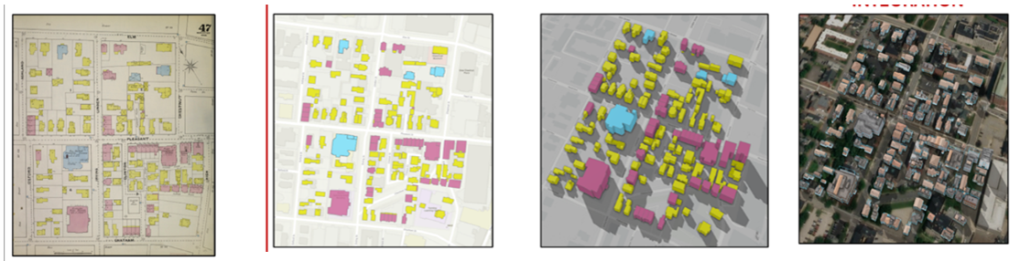
- UCA Indoor GIS and Campus Navigation
Objectives
- Create digital floor plans for selected UCA buildings.
- Build GIS layers for rooms, hallways, stairs, elevators, and entrances.
- Collect information about accessibility and campus facilities.
- Develop an indoor routing network for navigation.
- Explore QR codes, Wi-Fi, or other methods for indoor positioning.
- Design a mobile-friendly campus navigation application.

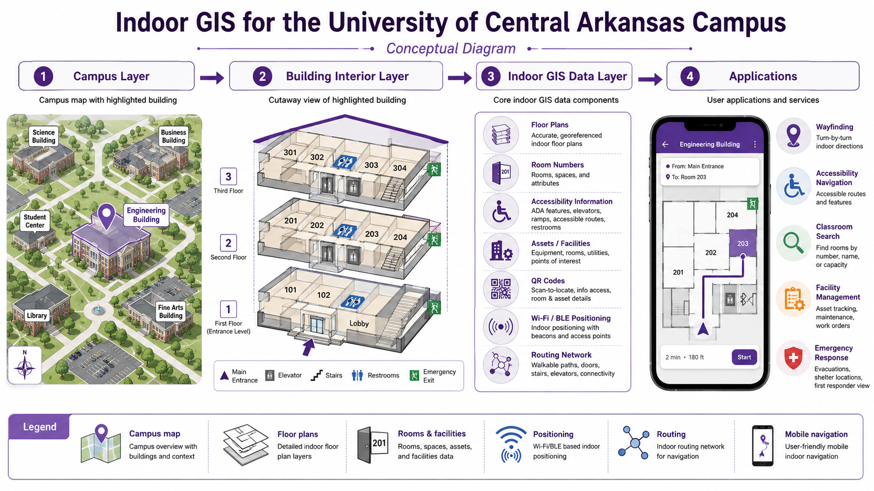

- Campus LiDAR and 3D Point Cloud Mapping
Objectives
- Learn what LiDAR and point-cloud data are.
- Visualize and classify 3D point-cloud data.
- Identify buildings, trees, ground, and other features from point clouds.
- Create 3D representations of campus or local environments.
- Measure features such as building height or tree height.
- Explore how point clouds support planning, environmental studies, and 3D GIS.

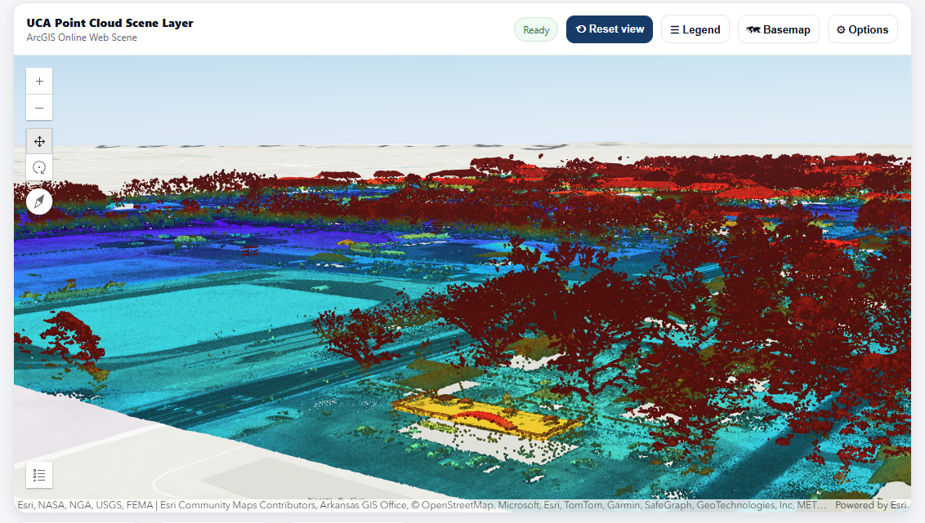
- AI-Assisted Road Condition Mapping
Objectives
- Collect or explore street-level road imagery.
- Identify visible pavement problems such as cracks, patches, or surface damage.
- Use AI/computer vision to assist with road-condition classification.
- Connect road-condition observations with GIS locations.
- Create a GIS layer showing road-condition categories.
- Prioritize road segments that may need inspection or maintenance.

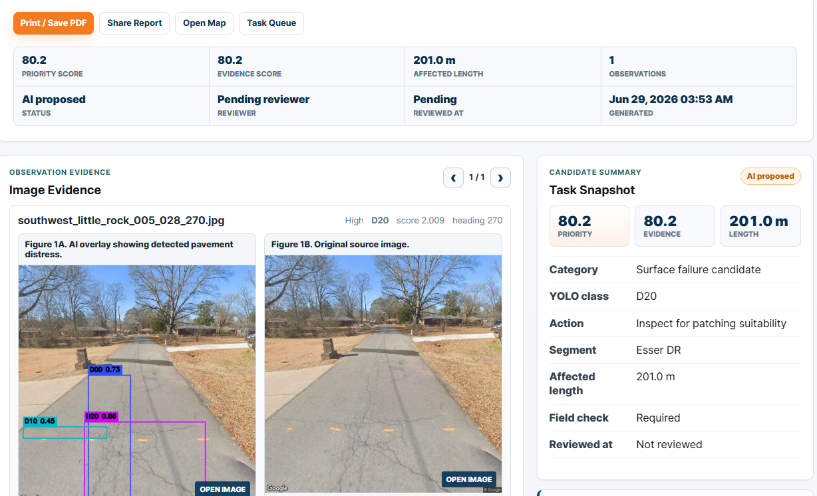

- Where Geography Comes Together: Building the UCA Geography GeoHub
Objectives：
- Design a digital home for UCA Geography that brings together maps, projects, research, courses, and field activities.
- Organize and share geographic information using ArcGIS Online and ArcGIS Hub.
Develop interactive maps, StoryMaps, dashboards, or other GIS applications to showcase departmental activities.
- Create engaging pages that highlight student projects, faculty research, field experiences, and community partnerships.
- Explore ways to make geographic data, maps, and resources easier for students and the public to discover and use.
- Examine how a GIS-based digital hub can support outreach, collaboration, student recruitment, and community engagement.
